

**AFRIK CURLEW**

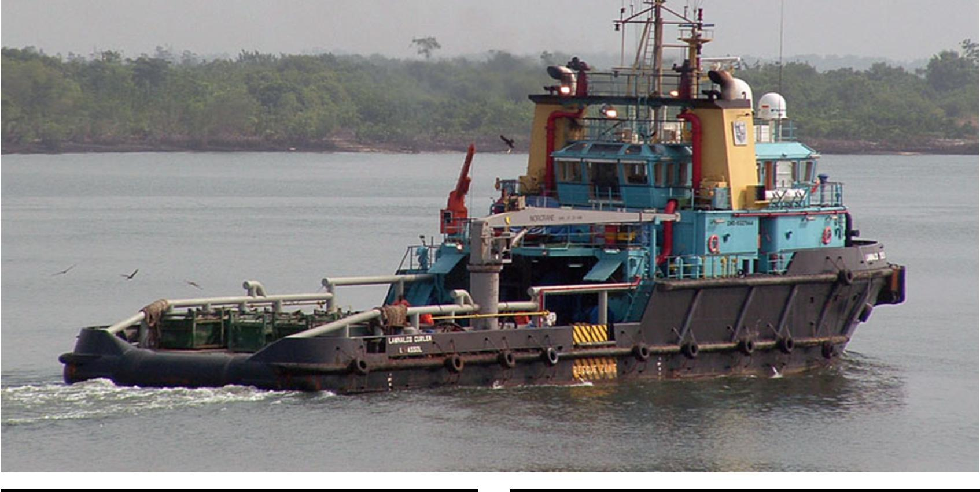

**GENERAL**

**bureau veritas | hull mach tug fire fighting ship 1 – water spraying unrestricted navigation**

**delivery date: july 2005**

**imo number: 9327944**

**DIMENSION**

**length over all: 47.40 m**

**beam over all: 12.60 m**

**maximum draught: 4.50 m**

**gt: 906**

**MACHINERY/ PROPULSION**

**main engines: 2 x wartsila 6r32**

**total power: 4, 920 kw**

**propulsion: 2x controllable pitch conventional**

**bow thruster: 1 x 300 kw**

**PERFORMANCE**

**bollard pull (ahead): 84 t**

**speed ahead (maximum) 15 knots**

**speed (economic) 11 knots**

**TANK CAPACITY**

**fuel oil 410 m3**

**portable water 280 m3**

**foam 20 m3**

**ACCOMODATION**

**accomodation, air conditioned for 18 persons**

**deck area**

**deck area (aft) 200 m3**

**DECK EQUIPMENT – FORE**

**fore winch hydraulic**

**single drum – 100 t. brake load**

**line pull 10** [**t.@25m/min**](mailto:T.@25m/min)**. on first layer**

**DECK EQUIPMENT – AFT**

**aft winch hydraulic**

**waterfall (2 drums) – 200 t.brake load**

**upper drum – line pull 100 t. @ 5m/min. on 1st layer**

**lower drum -– line pull 20 t. @ 5m/min. on 1st layer**

**stern roller 4.5m. x 2.2m., 200swl**

**tugger winch (es) 2 x karmoy 240 t.swl**

**towing pins 2 x karmoy 240t.swl**

**stopper pins 1 x karmoy 300 t.**

**OTHER EQUIPMENT**

**capacity fire-fighting monitors 2 x 1200 m3/hr**

**crane 3t swl. @ 14m. outreach**

